## A PROJECT REPORT

**ON**

# Online Job Portal

***Submitted by***

**Mahek Katariya (16IT416) Nigam Patel (16IT419) Harsh Shah (16IT435)**

### For Partial Fulfillment of the Requirements for Bachelor of Technology in Information Technology

**IT446: Major Project**

**Guided by Prof. Bijal Dalwadi**

**April, 2020**



## Information Technology Department

**Birla Vishvakarma Mahavidyalaya Engineering College (An Autonomous Institution)**

## Vallabh Vidyanagar – 388120 Gujarat, INDIA

|  |  |
| --- | --- |
| http://bvmengineering.ac.in/images/BVM%20Logo-1.png | **Birla Vishvakarma Mahavidyalaya Engineering College**  **(An Autonomous Institution)**  **Information Technology Department**  **AY: 2019-20, Semester II** |

CERTIFICATE

This is to certify that the project work entitled **Online Job Portal** has been

successfully carried out by **Mahek Katariya(16IT416), Nigam Patel(16IT419),**

**Harsh Shah(16IT435)** for the subject **IT446-Major Project** during the academic

year 2019-20, Semester-II for partial fulfilment of Bachelor of Technology in Information Technology. The work carried out during the semester is satisfactory.

|  |  |
| --- | --- |
| **Prof. Bijal Dalwadi**  Guide, IT Department BVM | **Dr. Keyur Brahmbhatt**  Head, IT Department BVM |

# Acknowledgement

This Major Project would not have been possible without the help of many people. Hereafter, we would like to thank them for their help, support, and advice they have given us while working on the project.

First, we would like to thank our Major Project guide, Prof. Bijal Dalwadi for her guidance, help, and the many discussion sessions that gave us courage and enthusiasm to design and build this application. We thank all the faculties of IT Dept, BVM for their support and guidance. We extend our gratitude to HOD of IT department, Dr. Keyur Brahmbhatt.

Also, I would like to thank our company mentor Snehal Patel. She will help us a lot to solve the error and give his precious time to us for the development of this project. Finally, we would like to thank our college, Birla Vishvakarma Mahavidhyalaya Engineering college for this opportunity to work on this project.

# Abstract

Job portal service was developed for creating an interactive job vacancy form for candidates. This web application manage updates both from the job seekers as well as the companies. It’s unique development methodology helps in acquiring the client and candidate information and separating them according to the job requirements and vacancies.

The online access to it provides details of the job. An employer being registered in the web site has the facility to use the services. Being an authorized user he can publish vacancy details and can search no of Employees on portal and also he can search candidates on basis of the key skill which employee provides on registration.

**Table of Contents**

Chapter 1 : Introduction 1

* 1. Brief Overview of Work 1
  2. Objective 1
  3. Scope 1
  4. Project Modules 2
     1. Registration 2
     2. Search 2
     3. Job Post 2
     4. Manage Account 2
  5. Project Requirements 3
     1. Hardware 3
     2. Software 3
  6. Company Profile 3

Chapter 2 : System Analysis 4

* 1. Literature Review 4
  2. Project Feasibility Study 5
     1. Technical Feasibility 5
     2. Economical Feasibility 5
     3. Operational Feasibility 5
  3. Project Timeline Chart 6
  4. Detailed Module Description with all Functionalities 7
     1. Registration 7
     2. Job Post 7
     3. Search 7
     4. Manage Account 7

Chapter 3 : System Design 8

* 1. Use Case Diagrams 8
  2. Data Flow Diagrams 9
  3. Class Diagram 11
  4. Entity Relationship Diagram 12
  5. Activity Diagram 12
  6. Data Dictionary 15

Chapter 4 : Implementation and Testing 25

* 1. User Interface and snapshots 25
  2. Test Cases and Result 34

Conclusion & Future work 39

References 40

**List of Figures**

Figure 1- Timeline chart 6

Figure 2- Usecase Diagram 8

Figure 3- DFD 0 level Diagram 9

Figure 4- DFD 1 level Diagram 9

Figure 5- DFD 2 level Diagram 10

Figure 6- Class Diagram 11

Figure 7- ER Diagram 12

Figure 8- Employer Activity Diagram 12

Figure 9- Employee Activity Diagram 13

Figure 10- Admin Activity Diagram 14

Figure 11- Home page I 25

Figure 12- Home page II 25

Figure 13- Employer Registration page-I 26

Figure 14- Employer Registration page-II 26

Figure 15- Employee key skill page 27

Figure 16- Employee wish list page 27

Figure 17- Employee my jobs page 28

Figure 18- Employee my account page 28

Figure 19- Employee message page 29

Figure 20- Employer home page 29

Figure 21- Employer job post page-I 30

Figure 22- Employer job post page-II 30

Figure 23- Employer my job page 31

Figure 24- Employer view applicant page 31

Figure 25- More detaisl job page-I 32

Figure 26- More details job page-II 32

Figure 27- Admin page 33

**List of Tables**

Table 1- employer table 15

Table 2 – employee table 16

Table 3- job_category table 17

Table 4- job table 18

Table 5- job_applications table 19

Table 6- like_log table 20

Table 7- comments table 21

Table 8- watchlist table 22

Table 9- message table 23

Table 10- feedback table 24

Table 11- city table 24

Table 12- Test Case 34

# Chapter 1 : Introduction

## Brief Overview of Work

Now a day, we know that searching of jobs is so difficult in proficient areas the portal developed for the providing the simple and good job searching. With the help of this portal easily the job seeker can submit their resume and get the lot of opportunity of the job related to their profile. And by this website the companies or employer can also find the good and well profiled resume.

## Objective

The online job Portal System that is to be developed provides the members with jobs information, online applying for jobs and many other facilities. This system provides service to the job applicants to search for working opportunities.

Job Portal will allow job provider to establish one to one relationships with candidates. This Portal will primarily focus on the posting and management of job vacancies. This system is designed such that ultimately all vacancies will be posted online and would offer employers the facilities to post their vacancies online. It helps to review and manage the resulting applications efficiently through the web. Employer can also find the resume according to key skill in very less amount of time.

## Scope

As of Indian market, there is ample opportunities for the job portal sites, as more and more number of educated and skilled young people are coming out each and every year. Also, as the growth rate of India is zooming to be at a healthy rate over 7%, so it is boom time for corporate also. So, more and more number of lucrative careers will be available for the job seekers. So, it is now the right period for the job portal sites to think out of the box, and to make most of the opportunities available.

## Project Modules

### Registration

Employee or Employer can register with valid details like contact details, experience details, profile details.

### Search

Employee Can Search job according to their interest. And also apply for that job.

Employer search candidates for their requirements using keyword. Employer also can communicate with employee for their any other query or information via send message.

### Job Post

Employer post job for their organization. And include job vacancy, salary details, working hours, designation details, experienced details.

### Manage Account

Employee can also delete his/her account anytime.

Admin Can Manage Employee and Employer Details. Admin observed Users Action like job posting, candidate details false or not.

## Project Requirements

### Hardware

The system requires the following hardware:

* + - * RAM: 1 GB (further increase that as per requirement.)
      * Hard Disk: 80 GB (further increase that as per requirement.)
      * Display: 1024 * 768, True Type Color-32 Bit
      * Mouse: Any Normal Mouse.
      * Keyboard: Any window Supported Keyboard.

### Software

* + - * Database Server : Microsoft SQL Server
      * Web Server : Internet Information Server
      * Technologies : HTML,CSS,ASP.NET,JavaScript,JQuery

## Company Profile

TatvaSoft is a CMMi Level 3 and Microsoft Gold Certified Software Development company that offers custom software development services on diverse technology platforms, like Microsoft, Java, PHP, Open Source, BI, and Mobile.

With rich and varied experience of 18+ years in software development and stringent quality standards, we offer utmost qualitative, on-time and cost-effective software solutions. We serve clientele across the industries and globe with Offices in US, Canada, UK, Australia and Development Center in India with a workforce of 810+ IT professionals.

We specializes in solving complex business challenges using thought process and information technology, and so far we have successfully completed 1800+ projects with 700+ SMEs and Fortune 500 companies.

# Chapter 2 : System Analysis

## Literature Review

Job Procurement: Old and New Ways Job seeking usually involves different ways to look for jobs such as through personal contacts, direct telephone calls to employers, job agency office, scanning online job listings, etc. Before the Internet, became widely uses as a method of seeking jobs, jobseekers spent a lots of time using various methods to look for job openings. Today, jobseekers use online methods which are very convenient and save a lot of time. Galanaki lists the following methods to be the traditional (old) ways for recruitment:

* + 1. Employment recruitment agencies
    2. Job fairs
    3. Advertising in the mass media such as newspapers
    4. Management Consultants
    5. Advertisement in television and radio
    6. Existing employee contacts
    7. Schools colleges or universities students services department
    8. Workers or professional referrals

These old job seeking methods are too slow, stressful, challenging and also lack quality. In addition, the applicants have to consider the cost and the amount of time to get the information they need, and other preparations they have to make. Finding all available job vacancies is a main step at in the job-seeking process. The Internet is now a powerful tool that jobseekers can use. Today, there are many sites that advertise job positions to be filled by people with certain skills in various fields. The Internet plays an important role in the area of human resource planning and development. Most planning and development organizations are now using computer technology and the Internet for staff recruitment. It should be noted that although the Internet has facilitated the process of job-seeking, it has not replaced the traditional methods, completely.

### Importance of Job Portals

In the age of technology, the Internet has become the main source of information for jobseekers. Large corporations, Institutions, and universities include information on career Prospects on their websites. According to a survey, 70% of the workforce uses websites or portals on the Internet to

Search for jobs in France. These websites or portals provide search engine to access information on job opportunities.

## Project Feasibility Study

### Technical Feasibility

Technical feasibility study is concerned with specifying equipment and software that will successfully satisfy the user requirement; the technical needs of the system may vary considerably.

The facility to produce outputs in a given time. Our project is a web based application which is based on client-server based application. In this application every page as output is render from server to client so it is necessary that the page should be rendered in time. For this I have avoided more and more code in the page- load event.

### Economical Feasibility

Economical feasibility is the measure to determine the cost and benefit of the proposed system. A project is economical feasible which is under the estimated cost for its development. These benefits and costs may be tangible or intangible. Job Portal is the cost-effective project in which there is less possibility of intangible cost so there is no difficulty to determine the cost of the project.

### Operational Feasibility

Operation feasibility is used to check whether the project is operationally feasible or not. Our project is mainly different from the other system because of its web-support feature. So the measure for operational feasibility is something different from other system. Generally the operational feasibility is related to organization aspects.

The change determination is as such that early product were either a man or group of men or the jobs based manual but now a day with the advent of Internet technology.

## Project Timeline Chart

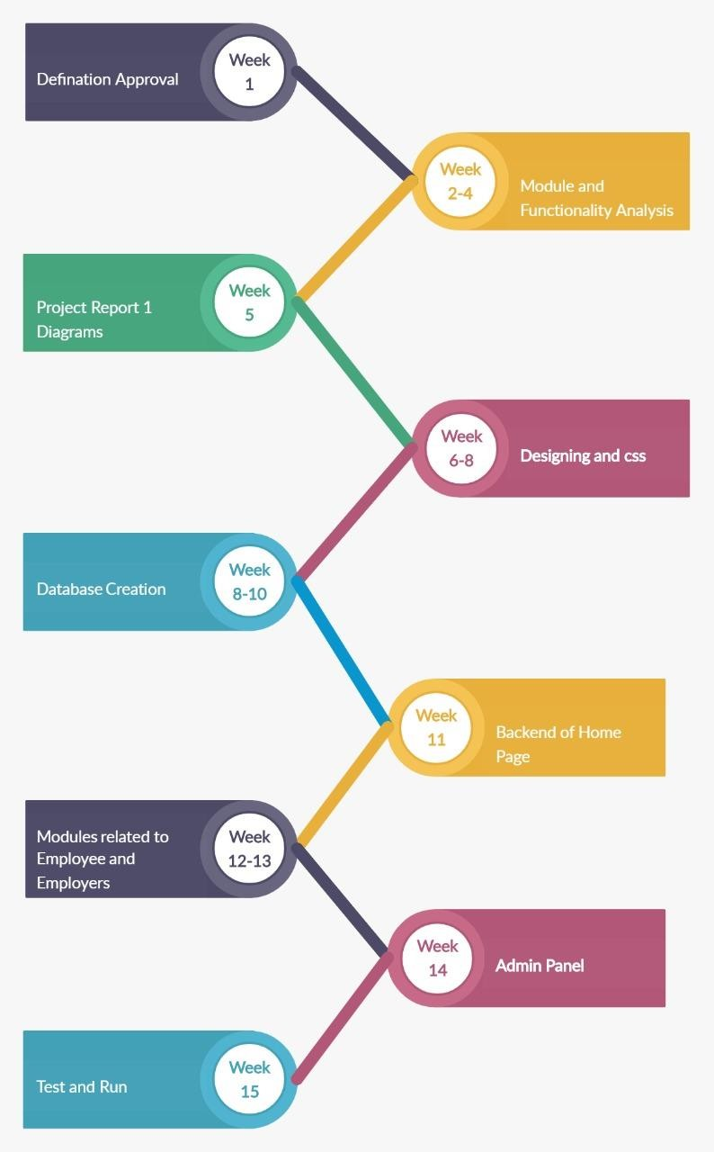

*Figure 1- Timeline chart*

## Detailed Module Description with all Functionalities

### Registration

In the registration module job seeker have to include all the details like personal details, contact details, education details like school , graduation, post-graduation, course certification details etc. Also job seeker has to add his experience details, job requirements and uploading resume and photo.

While job recruiter has to add his contact details and organization details for the registration and upload company logo and profile.

### Job Post

Employer can post a job by providing all the job details like qualifications details, requirements for the job, designation details, job salary details and also provide type of jobs. They also can delete the jobs whenever they want. After successfully posted a job it will be available for all the job seekers who are searching for a job. And it will be available on home page as recently posted job.

### Search

Employee Can Search job according to their interest. And also apply for that job or they can add into wishlist for future whenever they find for job for that company then they easily find out company from wishlist.

Employer search candidates for their requirements using keyword like technology. And also can communicate with employee for their any other query or information via send message .and also employer see the resume of applicants.

### Manage Account

While employers can manage their job postings. And providing all the job details like qualifications details, requirements for the job, designation details, job salary details and also provide type of jobs. They also can delete the jobs whenever they want.

While employee can manage their wishlist, applied for job and also getting full details of employer. Employees can delete their account anytime. Also they can apply for the different jobs according to their interests

# Chapter 3 : System Design

## Use Case Diagrams

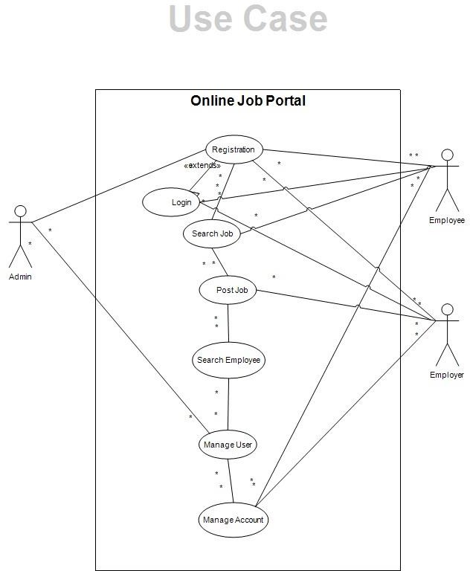

*Figure 2- Usecase Diagram*

## Data Flow Diagrams

### Context-Level (Level 0) DFD

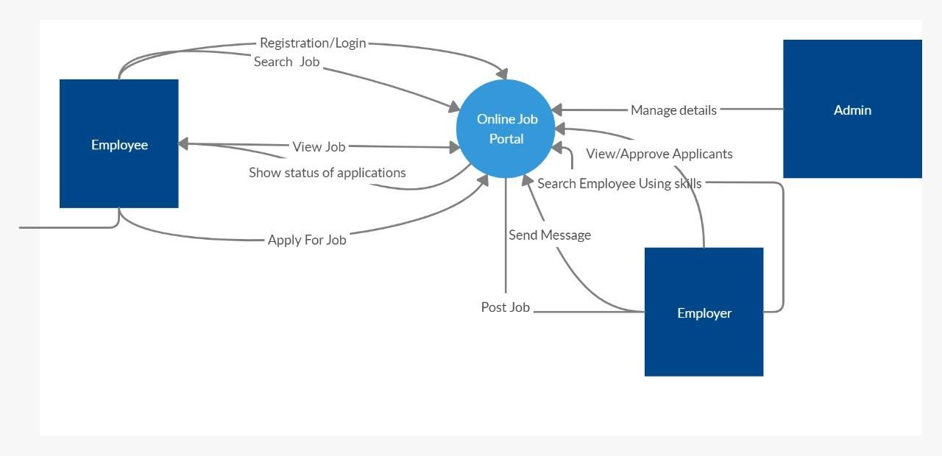

*Figure 3- DFD 0 level Diagram*

### 3.3.2 Level 1 DFD

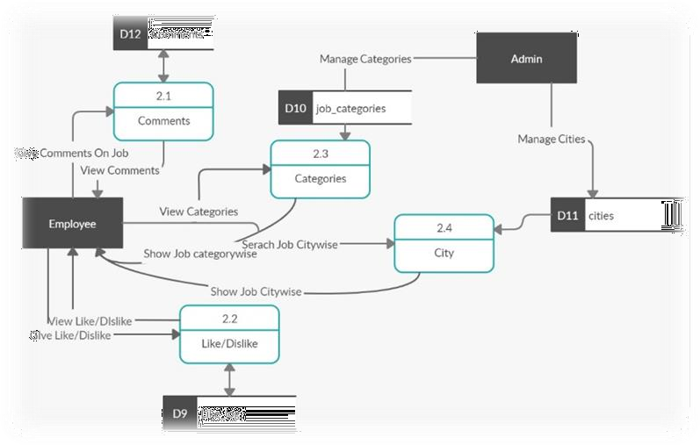

*Figure 4- DFD 1 level Diagram*

### 3.2.2 Level 2 DFD

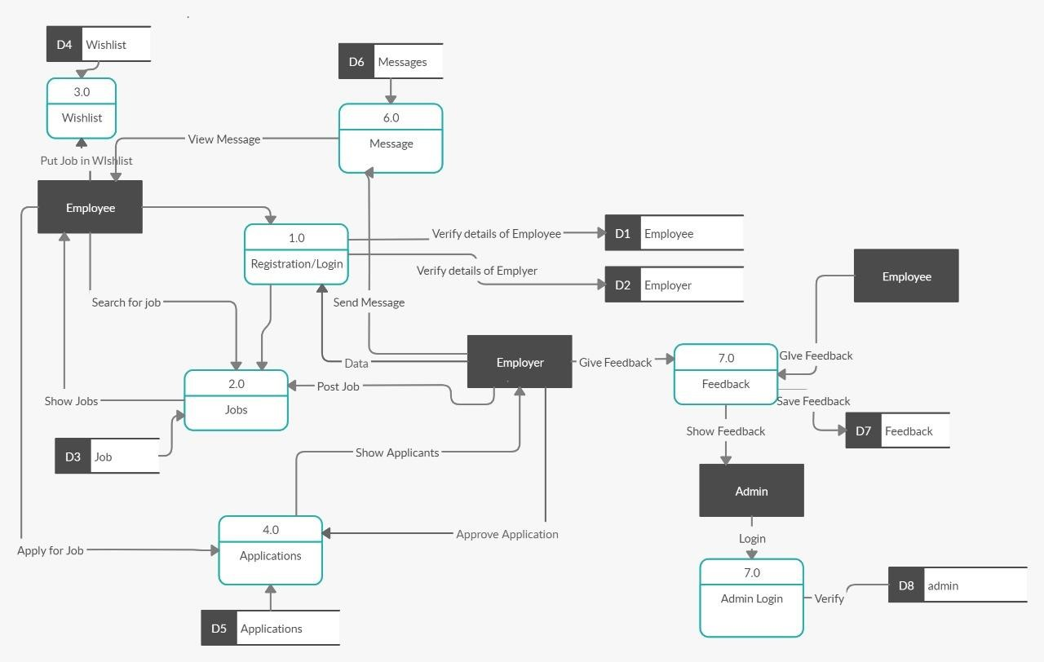

*Figure 5- DFD 2 level Diagram*

## Class Diagram

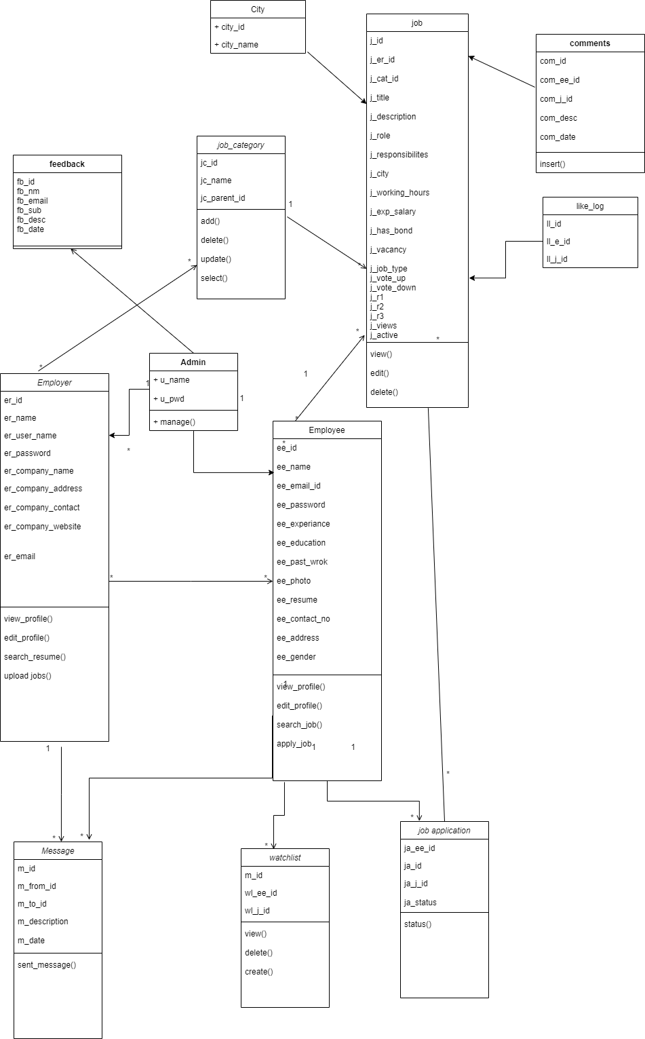

*Figure 6- Class Diagram*

## Entity Relationship Diagram

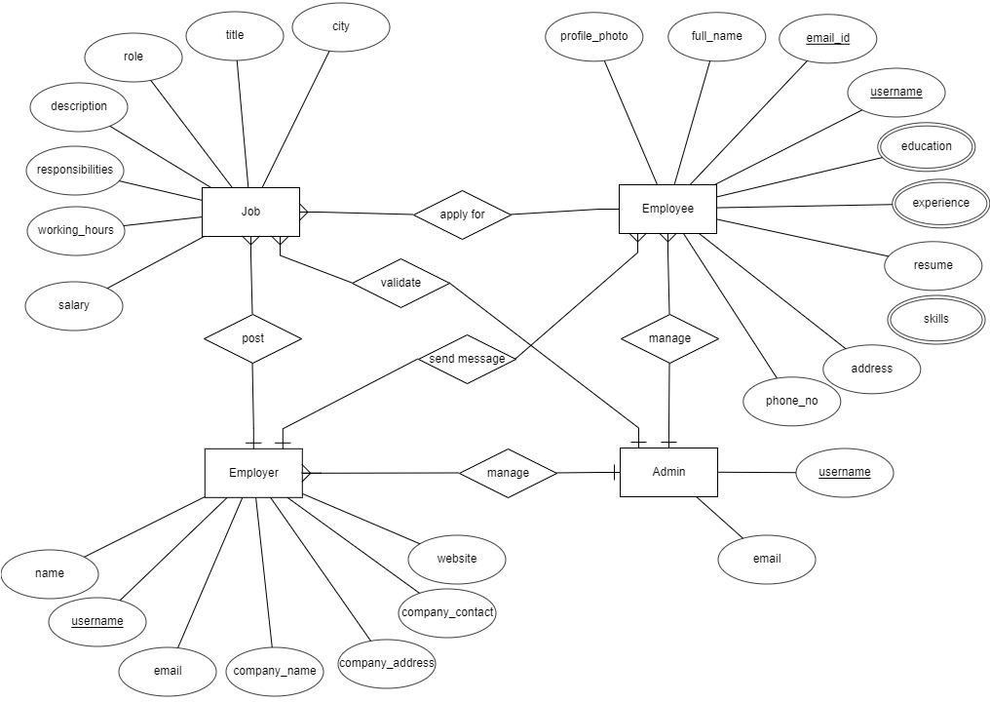

*Figure 7- ER Diagram*

## Activity Diagram

### Employer

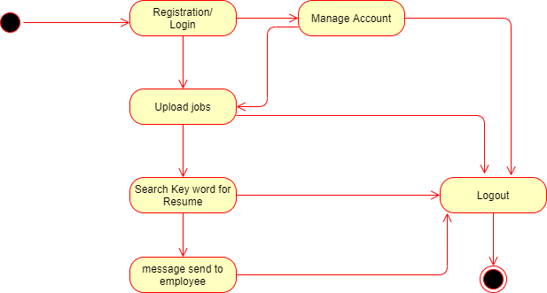

*Figure 8- Employer Activity Diagram*

### Employee

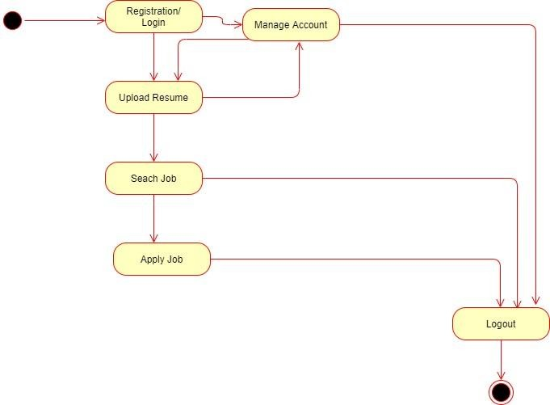

*Figure 9- Employee Activity Diagram*

### Admin

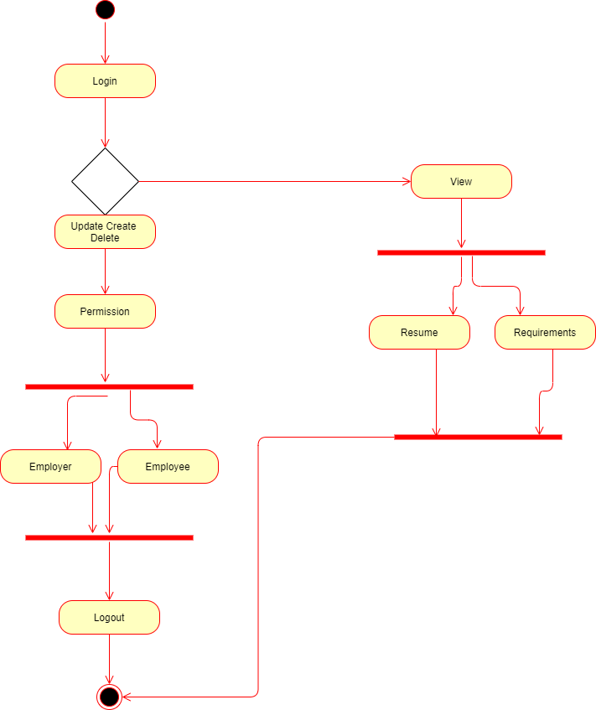

*Figure 10- Admin Activity Diagram*

## Data Dictionary

*Table 1- employer table*

|  |  |  |  |  |  |
| --- | --- | --- | --- | --- | --- |
| **Table 1:** | | | | | |
| **Name:** | | employer | | | |
| **Description:** | | Records information regarding employer. | | | |
| **Fields** | | | | | |
| **Sr.**  **No.** | **Field Name** | | **Field Type** | **Constraints** | **Description** |
| 1 | er_id | | int | primary key | Holds unique id of employer. |
| 2 | er_full_name | | varchar(50) | Null | Holds full name of the employer. |
| 3 | er_user_name | | varchar(50) | Null | Holds user name of the employer. |
| 4 | er_email | | varchar(50) | Null | Holds e-mail id of the employer. |
| 5 | er_pwd | | varchar(50) | Null | Holds password of employer. |
| 6 | er_comp_name | | varchar(50) | Null | Holds company name. |
| 7 | er_comp_address | | text | Null | Holds company address. |
| 8 | er_comp_phone | | varchar(20) | Null | Holds company phone number. |
| 9 | er_comp_web_add | | varchar(50) | Null | Holds company website URL. |
| 10 | er_comp_fax | | varchar(50) | Null | Holds company fax number. |
| 11 | er_comp_logo | | varchar(max) | Null | Holds company logo. |
| 12 | er_comp_profile | | varchar(max) | Null | Holds company profile |
| 13 | er_sec_que | | varchar(50) | Null | Holds security question |
| 14 | er_sec_ans | | varchar(50) | Null | Holds security answer |

*Table 2 – employee table*

|  |  |  |  |  |  |
| --- | --- | --- | --- | --- | --- |
| **Table 2:** | | | | | |
| **Name:** | | employee | | | |
| **Description:** | | Records information regarding employee. | | | |
| **Fields** | | | | | |
| **Sr.**  **No.** | **Field Name** | | **Field Type** | **Constraints** | **Description** |
| 1 | ee_id | | int | primary key | Holds the employee-id. |
| 2 | ee_full_name | | varchar(50) | Null | Holds full name of employee. |
| 3 | ee_user_name | | varchar(50) | Null | Holds user name of employee. |
| 4 | ee_email | | varchar(50) | Null | Holds email id of employee. |
| 5 | ee_pwd | | varchar(250) | Null | Holds password of employee. |
| 6 | ee_education | | varchar(50) | Null | Holds education detail of employee. |
| 7 | ee_experience | | Int | Null | Holds experience detail of employee. |
| 8 | ee_past_work | | Text | Null | Holds past work detail of employee. |
| 9 | ee_photo | | varchar(255) | Null | Holds photograph of employee. |
| 10 | ee_resume | | varchar(255) | Null | Holds resume of employee. |
| 11 | ee_phone_no | | varchar(50) | Null | Holds phone no of employee. |
| 12 | ee_address | | Text | Null | Holds address of employee. |
| 13 | ee_gender | | Char(1) | Null | Holds gender of employee. |

|  |  |  |  |  |
| --- | --- | --- | --- | --- |
| 14 | ee_sec_que | varchar(50) | Null | Holds security question of employee |
| 15 | ee_sec_ans | varchar(50) | Null | Holds security answer of employee |
| 16 | ee_first_login | int | Null | Holds status |
| 17 | ee_ks1 | varchar(50) | Null | Holds key skill 1 |
| 18 | ee_ks2 | varchar(50) | Null | Holds key skill 2 |
| 19 | ee_ks3 | varchar(50) | Null | Holds key skill 3 |
| 20 | ee_int_city | varchar(50) | Null | Holds interested city |
| 21 | ee_int_category | varchar(50) | Null | Holds interested category |
| 22 | ee_int_sub_category | varchar(50) | Null | Holds interested sub category |

*Table 3- job_category table*

|  |  |  |  |  |  |
| --- | --- | --- | --- | --- | --- |
| **Table 3:** | | | | | |
| **Name:** | | job_category | | | |
| **Description:** | | Record information about categories of job. | | | |
| **Fields** | | | | | |
| **Sr.**  **No.** | **Field Name** | | **Field Type** | **Constraints** | **Description** |
| 1 | jc_id | | Int | primary key | Holds id of job category. |
| 2 | jc_name | | varchar(50) | not null | Holds job category name. |
| 3 | jc_parent_id | | Int | foreign key | Holds id of parent category. |

*Table 4- job table*

|  |  |  |  |  |  |
| --- | --- | --- | --- | --- | --- |
| **Table 4:** | | | | | |
| **Name:** | | Job | | | |
| **Description:** | | Records information about job posted by recruiter. | | | |
| **Fields** | | | | | |
| **Sr.**  **No.** | **Field Name** | | **Field Type** | **Constraints** | **Description** |
| 1 | j_id | | int | primary key | Holds id of job. |
| 2 | j_er_id | | int | foreign key | Holds id of employer. |
| 3 | j_jc_id | | int | foreign key | Holds id of job category. |
| 4 | j_sub_cat_id | | Int | Foreign key | Holds id of job sub category |
| 5 | j_title | | varchar(150) | Null | Holds title of the job. |
| 6 | j_exp_required | | varchar(50) | Null | Holds job experienced required |
| 7 | j_min_edu | | varchar(50) | Null | Holds job minimum education |
| 8 | j_desc | | Text | Null | Holds description of job. |
| 9 | j_role | | Text | Null | Holds role of job. |
| 10 | j_respo | | Text | Null | Holds responsibilities of job. |
| 11 | j_city | | varchar(50) | Null | Holds city name of job. |
| 12 | j_work_hours | | Int | Null | Holds working hours detail of job |
| 13 | j_exp_salary | | varchar(50) | Null | Holds expected salary of job. |
| 14 | j_has_bond | | varchar(50) | Null | Holds information of bond information. |

|  |  |  |  |  |
| --- | --- | --- | --- | --- |
| 15 | j_vacancy | varchar(50) | Null | Holds information of vacancy |
| 16 | j_job_type | varchar(50) | Null | Holds information of job type |
| 17 | j_post_date | varchar(50) | Null | Holds information of job post date |
| 18 | j_vote_up | Int | Null | Holds information of job likes. |
| 19 | j_vote_down | Int | Null | Holds information of job dislikes. |
| 20 | j_views | Int | Null | Holds information of job views. |
| 21 | j_active | varchar(50) | Null | Holds information of job active or not |

*Table 5- job_applications table*

|  |  |  |  |  |  |
| --- | --- | --- | --- | --- | --- |
| **Table 5:** | | | | | |
| **Name:** | | job_applications | | | |
| **Description:** | | Records information about job application | | | |
| **Fields** | | | | | |
| **Sr.**  **No.** | **Field Name** | | **Field Type** | **Constraints** | **Description** |
| 1 | ja_id | | int | primary key | Holds the id of job application. |
| 2 | ja_ee_id | | int | foreign key | Holds the id of employee. |
| 3 | ja_j_id | | int | foreign key | Holds the information for which job applied. |
| 4 | ja_status | | varchar(50) | not null | Holds the status of application of job. |

*Table 6- like_log table*

|  |  |  |  |  |  |
| --- | --- | --- | --- | --- | --- |
| **Table 6:** | | | | | |
| **Name:** | | like_log | | | |
| **Description:** | | Records information about like. | | | |
| **Fields** | | | | | |
| **Sr.**  **No.** | **Field Name** | | **Field Type** | **Constraints** | **Description** |
| 1 | ll_id | | int | primary key | Holds id of like. |
| 2 | ll_ee_id | | int | foreign key | Holds id of employee. |
| 3 | ll_j_id | | int | foreign key | Holds id of job. |

*Table 7- comments table*

|  |  |  |  |  |  |
| --- | --- | --- | --- | --- | --- |
| **Table 7:** | | | | | |
| **Name:** | | comments | | | |
| **Description:** | | Records information about comment which user does. | | | |
| **Fields** | | | | | |
| **Sr.**  **No.** | **Field Name** | | **Field Type** | **Constraints** | **Description** |
| 1 | com_id | | int | primary key | Holds qualification type id |
| 2 | com_ee_id | | int | foreign key | Holds type of qualification like |
| 3 | com_j_id | | int | foreign key | Holds job id. |
| 4 | com_description | | Text | Null | Holds comment description. |
| 5 | com_date | | varchar(50) | Null | Holds date on which commented by user. |

*Table 8- watchlist table*

|  |  |  |  |  |  |
| --- | --- | --- | --- | --- | --- |
| **Table 8:** | | | | | |
| **Name:** | | watchlist | | | |
| **Description:** | | Record information about watchlist. | | | |
| **Fields** | | | | | |
| **Sr.**  **No.** | **Field Name** | | **Field Type** | **Constraints** | **Description** |
| 1 | wl_id | | Int | primary key | Holds unique id watch list. |
| 2 | wl_ee_id | | Int | foreign key | Holds watchlist id of employee. |
| 3 | wl_j_id | | Int | foreign key | Holds watchlist id of job |

*Table 9- message table*

|  |  |  |  |  |  |
| --- | --- | --- | --- | --- | --- |
| **Table 9:** | | | | | |
| **Name:** | | message | | | |
| **Description:** | | Records information about message sent by user. | | | |
| **Fields** | | | | | |
| **Sr.**  **No.** | **Field Name** | | **Field Type** | **Constraints** | **Description** |
| 1 | m_id | | number(10) | primary key | Holds the unique id for message id. |
| 2 | m_from_id | | number(10) | foreign key | Holds the id of sender. |
| 3 | m_to_id | | number(10) | foreign key | Holds the id of receiver. |
| 4 | m_description | | text(100) | Null | Holds the description regarding message. |
| 5 | m_date | | date | Null | Holds the date of message. |

*Table 10- feedback table*

|  |  |  |  |  |  |
| --- | --- | --- | --- | --- | --- |
| **Table 10:** | | | | | |
| **Name:** | | Feedback | | | |
| **Description:** | | Record information about feedback. | | | |
| **Fields** | | | | | |
| **Sr.**  **No.** | **Field Name** | | **Field Type** | **Constraints** | **Description** |
| 1 | fb_id | | Int | Primary Key | Holds unique id for feedback. |
| 2 | fb_nm | | varchar(50) | Null | Holds the name of feedback. |
| 3 | fb_email | | Varchar(50) | Null | Holds the email of sender |
| 4 | fb_sub | | varchar(50) | Null | Holds the subject of feedback. |
| 5 | fb_description | | Text | Null | Holds description of feedback. |
| 6 | fb_date | | varchar(50) | Null | Holds date of feedback. |

*Table 11- city table*

|  |  |  |  |  |  |
| --- | --- | --- | --- | --- | --- |
| **Table 11:** | | | | | |
| **Name:** | | City | | | |
| **Description:** | | Record information about city. | | | |
| **Fields** | | | | | |
| **Sr.**  **No.** | **Field Name** | | **Field Type** | **Constraints** | **Description** |
| 1 | city_id | | Int | Primary Key | Holds unique id for city. |
| 2 | city_name | | varchar(50) | Null | Holds the name of city. |

# Chapter 4 : Implementation and Testing

## User Interface and snapshots

### Home Page

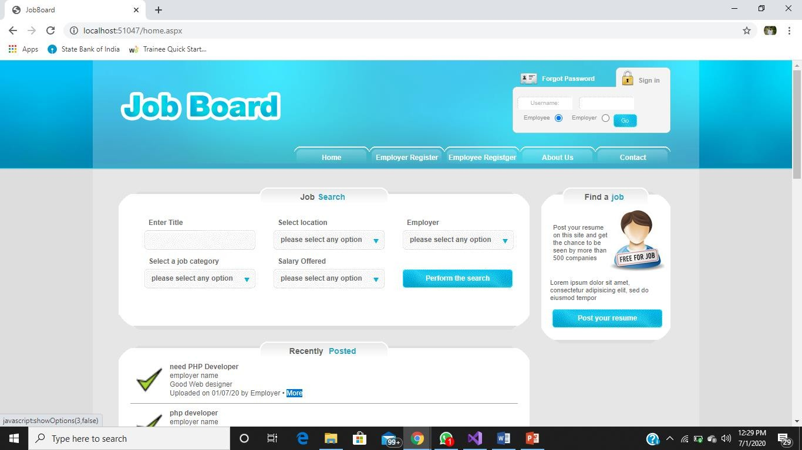

*Figure 11- Home page I*

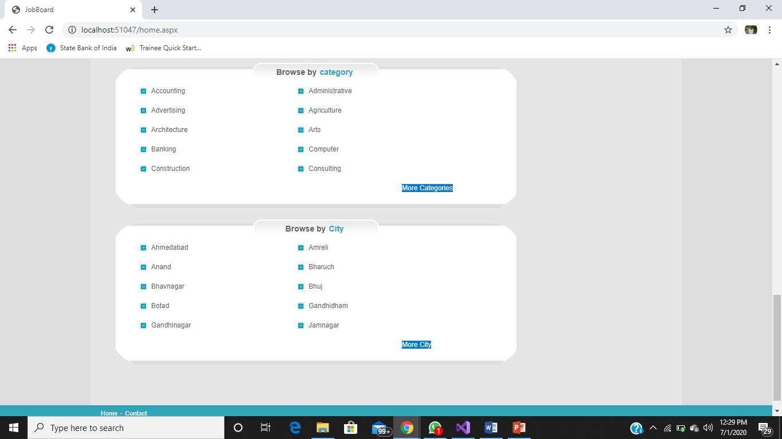

*Figure 12- Home page II*

### Employer Registration page

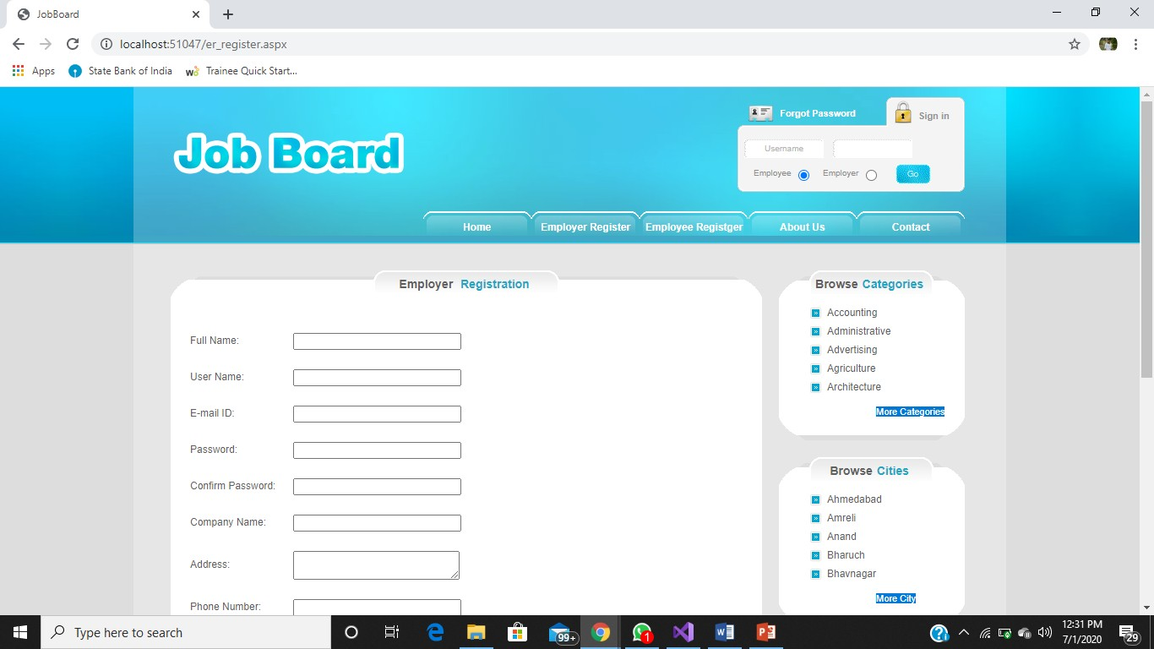

*Figure 13- Employer Registration page-I*

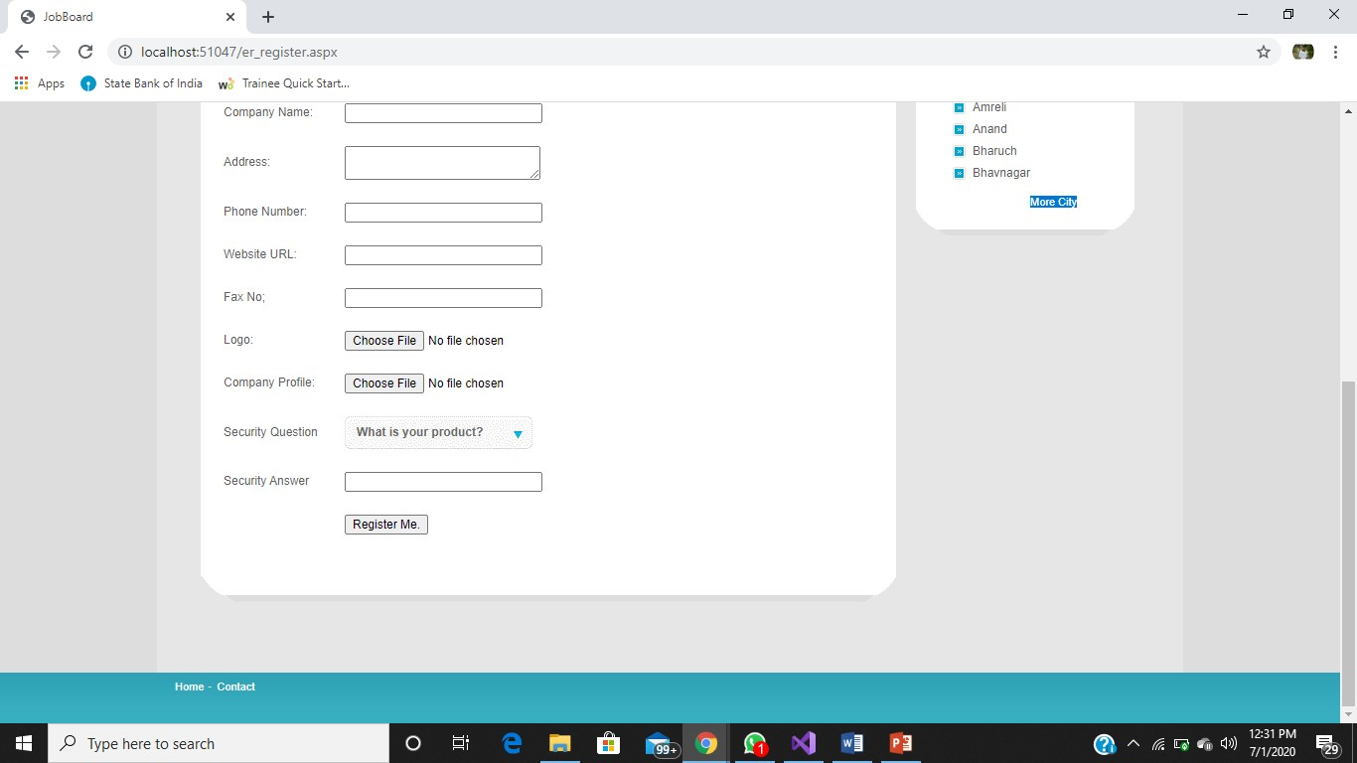

*Figure 14- Employer Registration page-II*

### Employee key skill page

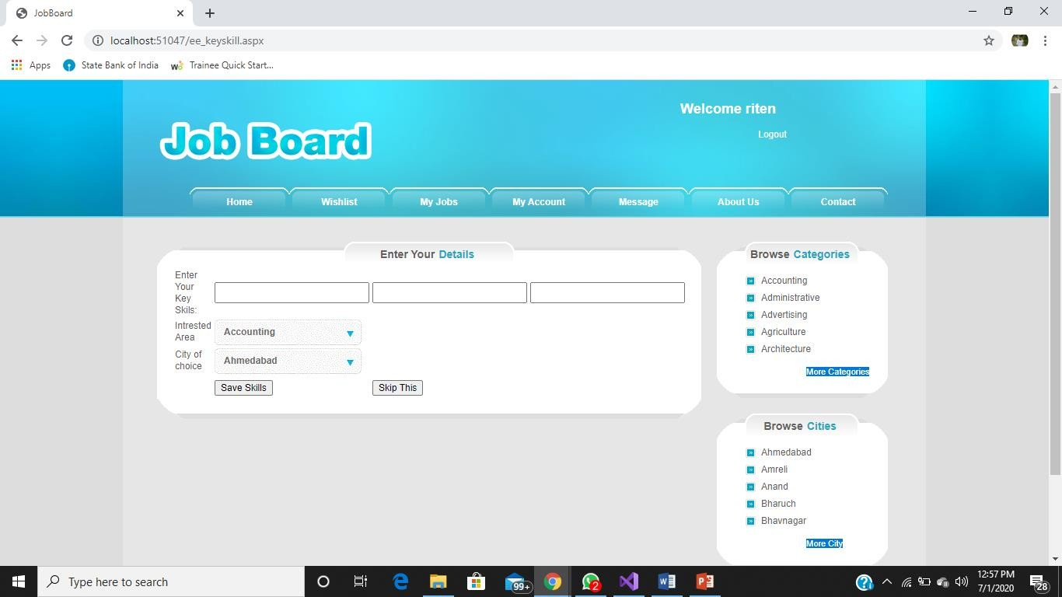

**Employee wish list page**

*Figure 15- Employee key skill page*

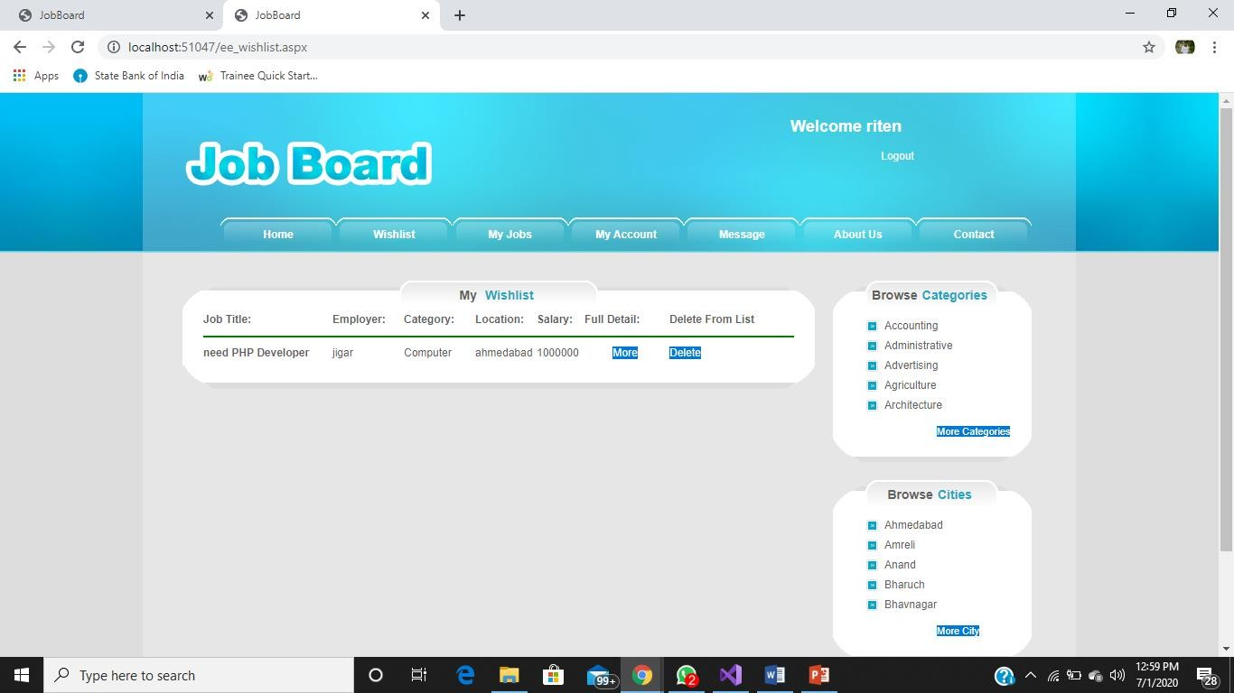

*Figure 16- Employee wish list page*

### Employee my jobs page

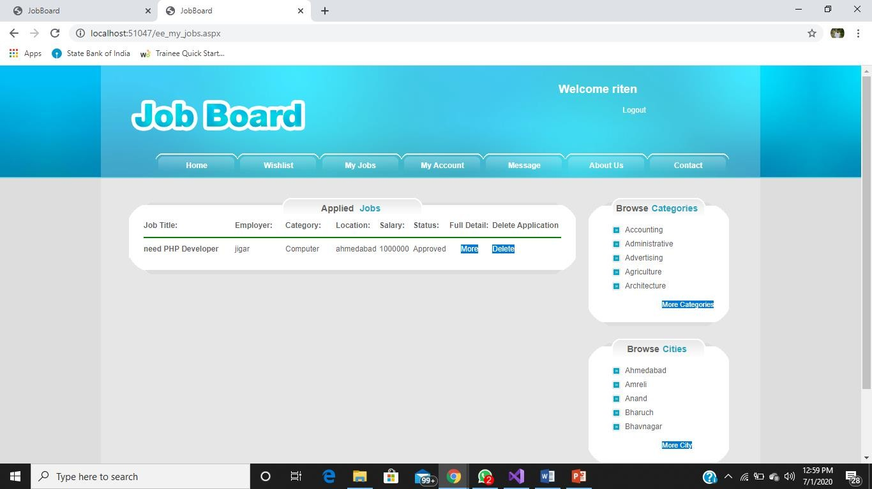

*Figure 17- Employee my jobs page*

### Employee my account page

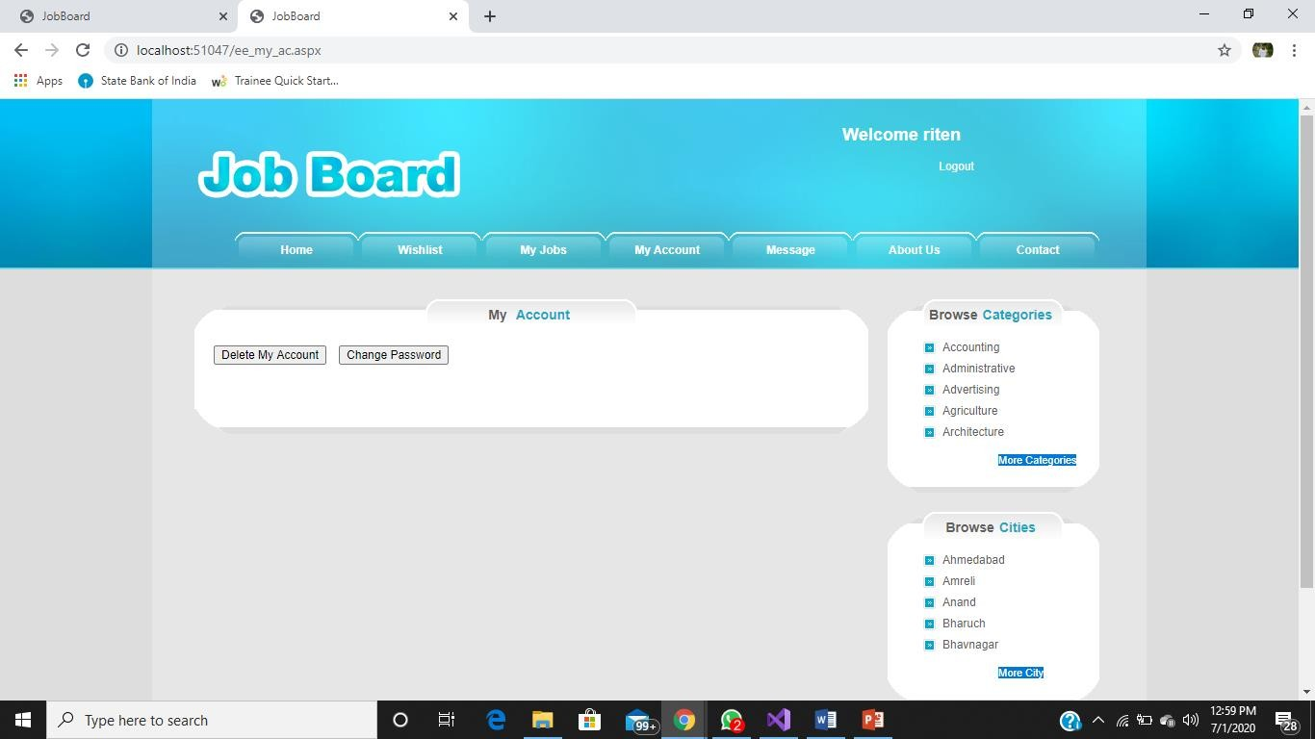

*Figure 18- Employee my account page*

### Employee message page

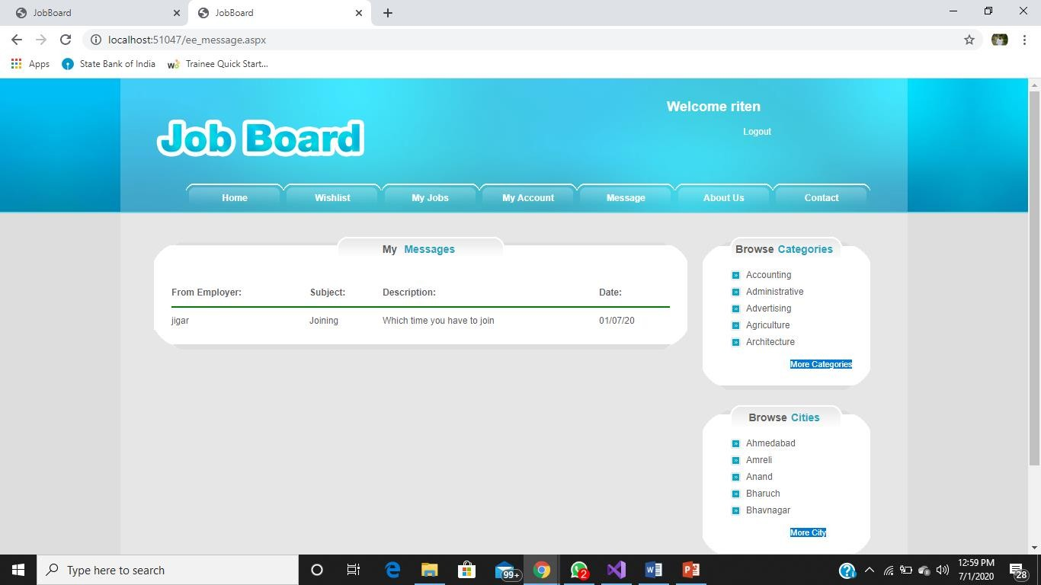

**Employer home page**

*Figure 19- Employee message page*

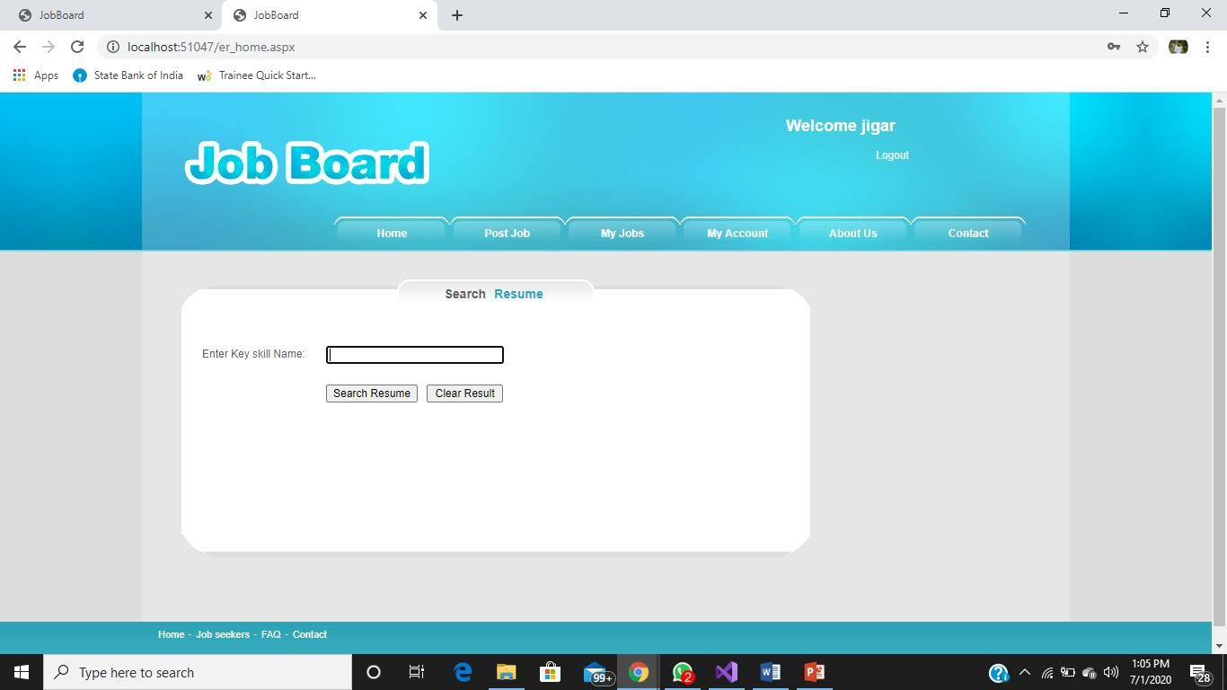

*Figure 20- Employer home page*

### Employer job post page

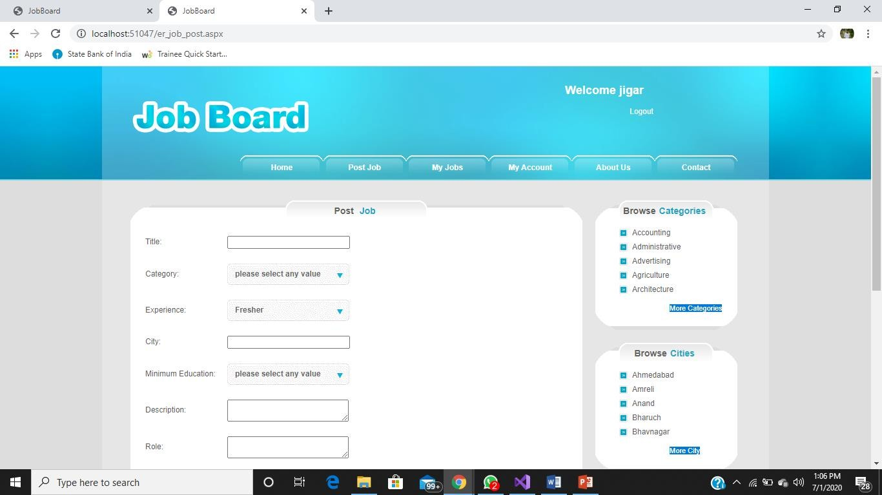

*Figure 21- Employer job post page-I*

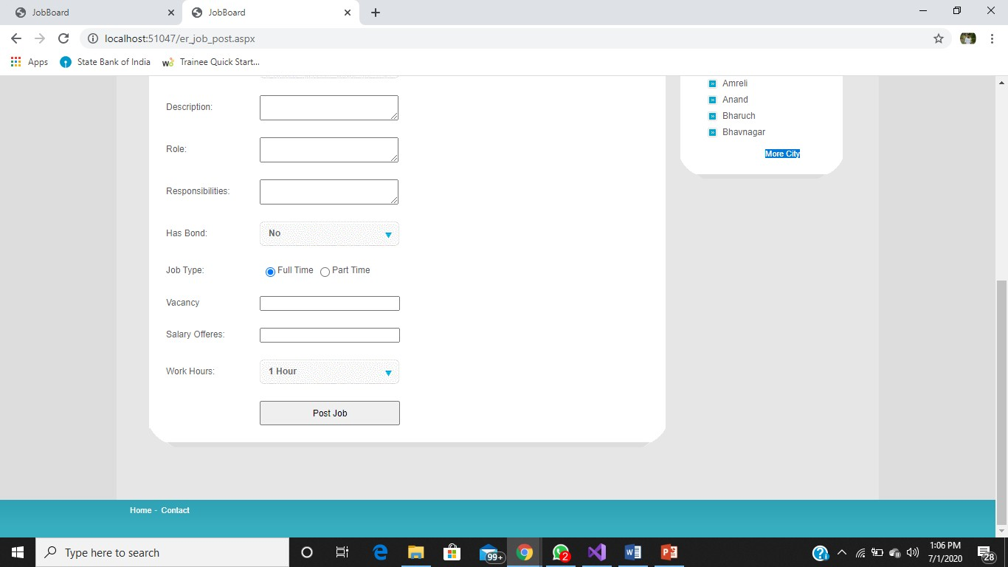

*Figure 22- Employer job post page-II*

### Employer my jobs page

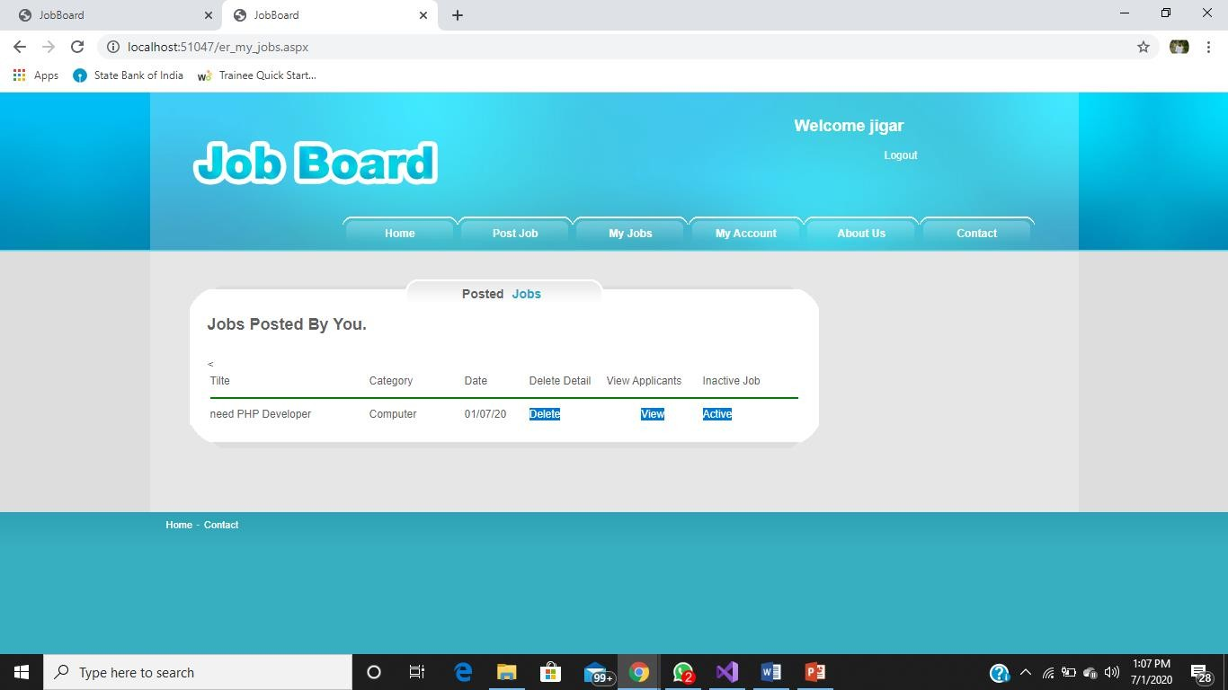

**Employer view applicant page**

*Figure 23- Employer my job page*

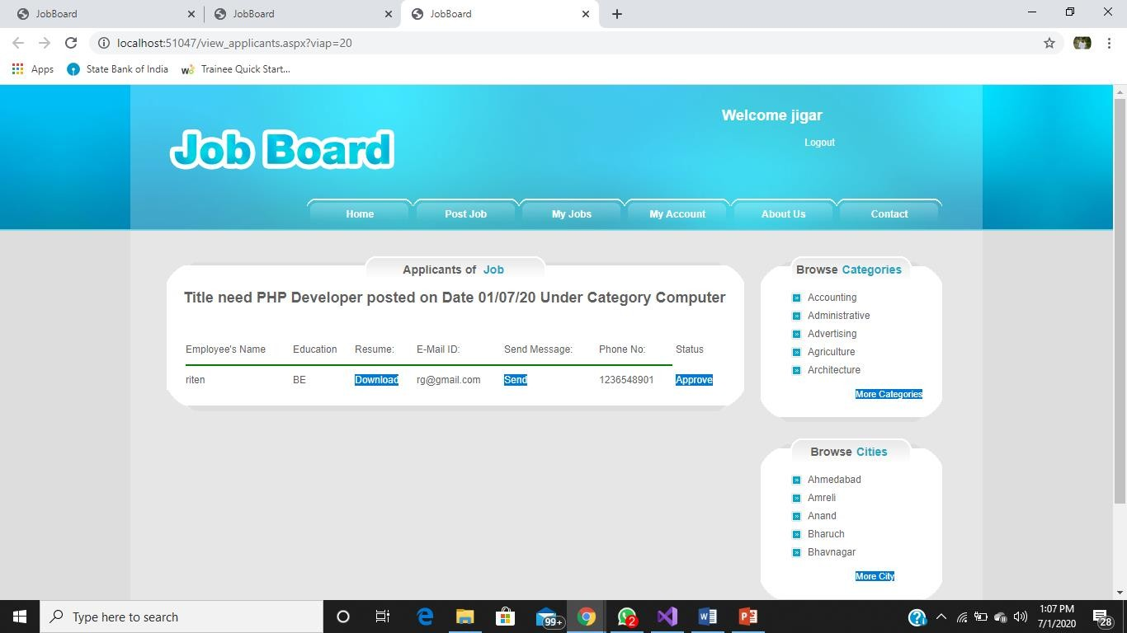

*Figure 24- Employer view applicant page*

### More details job page

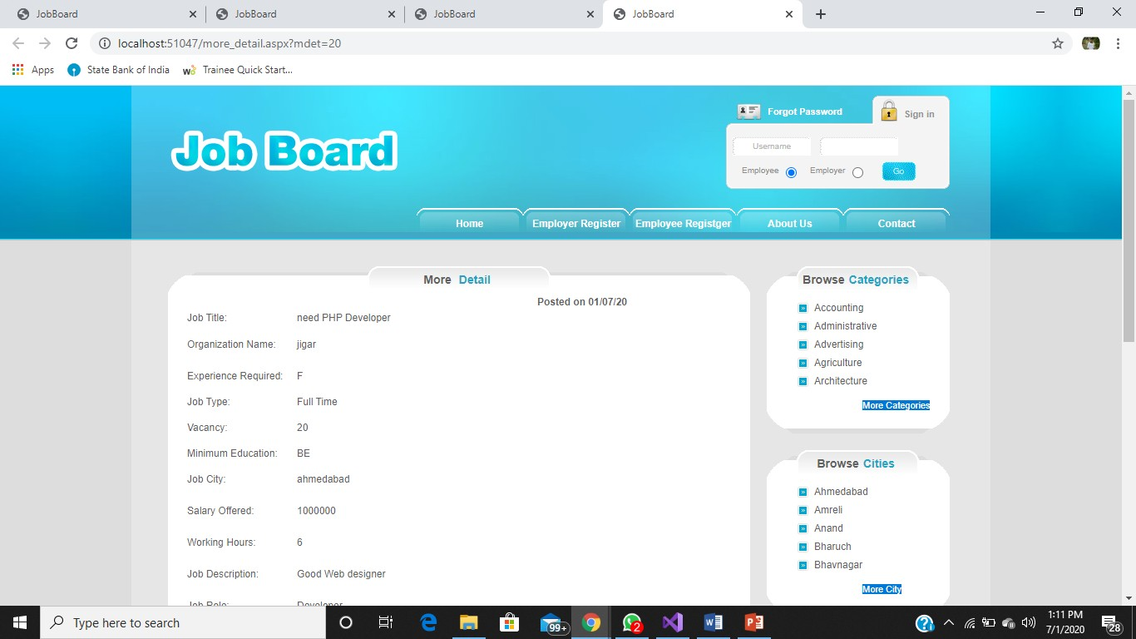

*Figure 25- More detaisl job page-I*

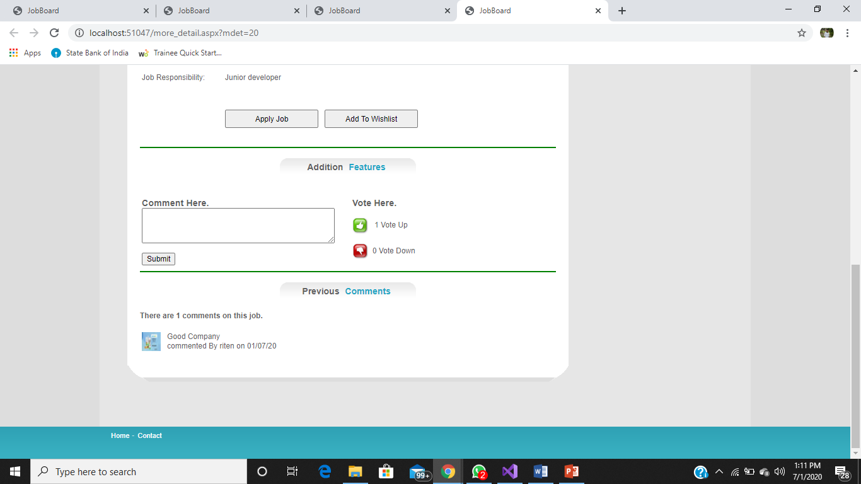

*Figure 26- More details job page-II*

### Admin Page

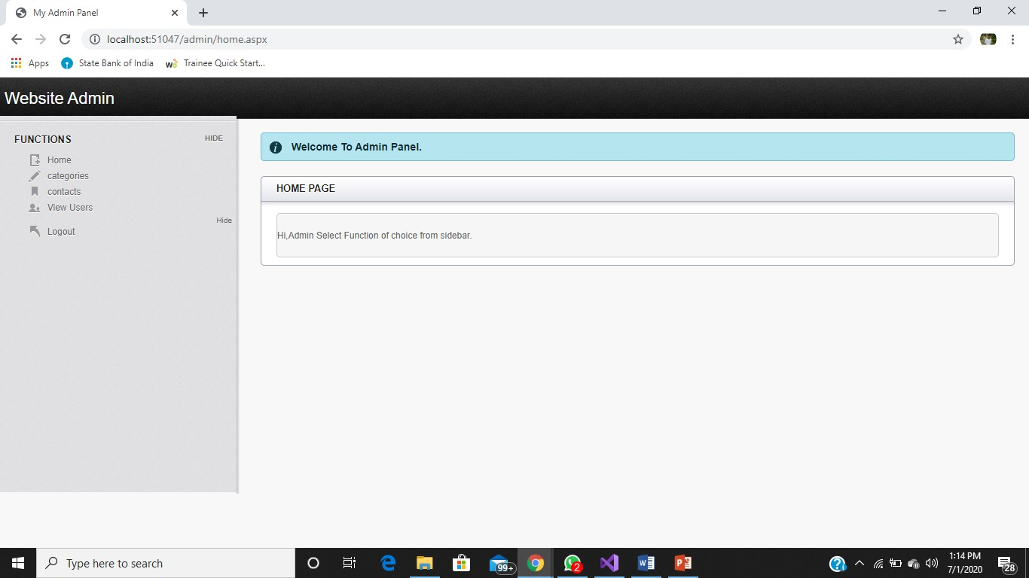

*Figure 27- Admin page*

## Test Cases and Result

*Table 12- Test Case*

|  |  |  |  |  |  |
| --- | --- | --- | --- | --- | --- |
| **Test Case Id** | **Test scenario** | **Test steps** | **Test data** | **Expected**  **result** | **Actual result** |
| UU01 | Create employer registration page | 1. Open website and clicked on employer  registration | Information of employer data to be added | Data is successfully added in employer  table | As expected |
| UU02 | Create employee registration page | 1. Open website and clicked on employee  registration | Information of employee data to be added | Data is successfully added in employee  table | As expected |
| UU03 | Crate login page for employer | 1. open website and clicked on employer radio button 2. enter username and   password | Employer enter valid data | Data is fetch from employer table | As expected |
| UU04 | Crate login page for employee | 1. open website and clicked on employee radio button 2. enter   username | Employer enter valid data | Data is fetch from employee table | As expected |

|  |  |  |  |  |  |
| --- | --- | --- | --- | --- | --- |
|  |  | and  password |  |  |  |
| UU05 | Post Job page for employer | Employer login successfully then they post your job | Employer filed necessary data to require for recruit  employee | Data is added successfully in Job table And also show home page in  trending job | As expected |
| UU06 | My job page for employer | Employer see the who is apply for posted job and also delete job and view applicant and active or inactive job them  self | Employer see the applicants, delete job, active or inactive job | Successfully delete job and active or inactive job, and also full details of applcants. | As expected |
| UU07 | View applicant page for employer | Employer see applicant name, education, email,id, Phone no and also download  resume and | Employee download the resume, send message, approved applicant | Successfully download the resume, send message to employee, and approved or not approved. | As expected |

|  |  |  |  |  |  |
| --- | --- | --- | --- | --- | --- |
|  |  | send message to employee for further query and approved applicant  them self |  |  |  |
| UU08 | Create my account page for employer | 1. click on change password then they can change password 2. click on delete account then they can delete account from portal | User change password then directly put new password. and delete account then first asked for security question and answer and it’s verify then delete  the account | Successfully change password and delete account | As expected |
| UU09 | Add skills page for employee | Add skills, interested category, and interested city | Employee add their skills, selected city, interested category and  also skip this | Successfully data added employee table | As expected |

|  |  |  |  |  |  |
| --- | --- | --- | --- | --- | --- |
| UU10 | Wishlist page for employee | 1.click on more details page of jobs then applied for add to wishlist | Employee see the employer name, category, location, salary, remove from wish list | Add into wishlist page successfully | As expected |
| UU11 | My jobs page for employee | 1.click on more details page of jobs then applied for add to my jobs | Employee see employer name, category , location, add to link for more details, check status of application it is approved or not and remove from  my jobs | Add into my jobs page successfully | As expected |
| UU12 | Create my account page for employer | 1. click on change password then they can change password 2. click on   delete account then | User change password then directly put new password.  And delete account then first asked for  security | Successfully change password and delete account | As expected |

|  |  |  |  |  |  |
| --- | --- | --- | --- | --- | --- |
|  |  | they can delete account from portal | question and answer and it’s verify then delete  the account |  |  |
| UU13 | Message page for employee | Which employer send message employee  can see | Employee see employer name, subject, Description,  date | Successfully data fetch from message table | As expected |
| UU14 | About us page | 1.click on about us  page | See the details of our | See the details of our | As expected |
| UU15 | Contact page | 1.click on contact page | User can any query then send message  us | See the message of sender from  admin side | As expected |

# Conclusion & Future work

It has been a great pleasure for me to work on this exciting and challenging project. This project proved good for me as it provided practical knowledge of not only programming in ASP.NET web based application and no some extent Windows Application and SQL Server, but also about all handling procedure related with online job portal. It also provides knowledge about the latest technology used in developing web enabled application and client server technology that will be great demand in future. This will provide better opportunities and guidance in future in developing projects independently.

# References

* + 1. Literature review on online job portal <https://ijarcce.com/upload/2017/may-17/IJARCCE%2019.pdf>
    2. <https://www.naukri.com/account/register/basicdetails>
    3. <https://corp.freshersworld.com/post-job?src=homeheader>
    4. <https://www.freshersworld.com/>